My_NoteBook

Sanjay Sane

2023-12-08

library(dplyr)

##   
## Attaching package: 'dplyr'

## The following objects are masked from 'package:stats':  
##   
## filter, lag

## The following objects are masked from 'package:base':  
##   
## intersect, setdiff, setequal, union

data("ChickWeight")  
chk_34 <- filter(ChickWeight, Chick==34)  
chk_34

## weight Time Chick Diet  
## 1 41 0 34 3  
## 2 49 2 34 3  
## 3 63 4 34 3  
## 4 85 6 34 3  
## 5 107 8 34 3  
## 6 134 10 34 3  
## 7 164 12 34 3  
## 8 186 14 34 3  
## 9 235 16 34 3  
## 10 294 18 34 3  
## 11 327 20 34 3  
## 12 341 21 34 3

## Scatter Plot

Weight Against Time

library(ggplot2)  
ggplot(data = chk_34, aes(x=Time, y=weight))+  
 geom_line()

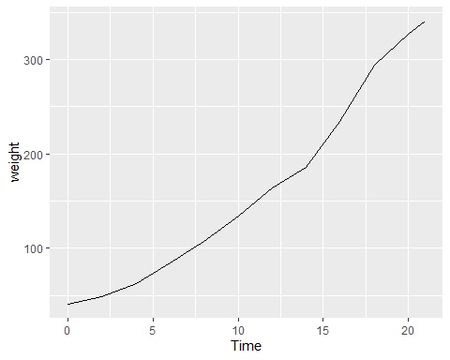

We can see the increasing trend over time.

chk_grp <- filter(ChickWeight, Diet==4)  
ggplot(data = chk_grp, aes(group=Time, y=weight))+  
 geom_boxplot()

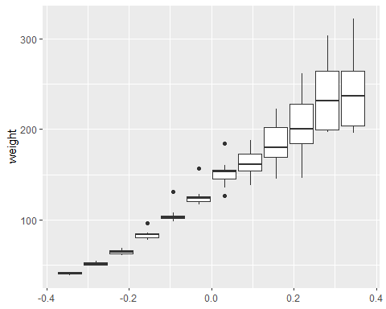

Compute the mean weight for chicks in group 4, for each time point. Plot this mean value against time.

mn_wt <- chk_grp %>%   
 group_by(Time) %>%   
 summarise(avg_weight=mean(weight))  
mn_wt

## # A tibble: 12 × 2  
## Time avg_weight  
## <dbl> <dbl>  
## 1 0 41   
## 2 2 51.8  
## 3 4 64.5  
## 4 6 83.9  
## 5 8 106.   
## 6 10 126   
## 7 12 151.   
## 8 14 162.   
## 9 16 182   
## 10 18 203.   
## 11 20 234.   
## 12 21 239.

Plot:

ggplot(data=mn_wt, aes(x=Time, y=avg_weight))+  
 geom_point()+ggtitle("Scatter Plot")

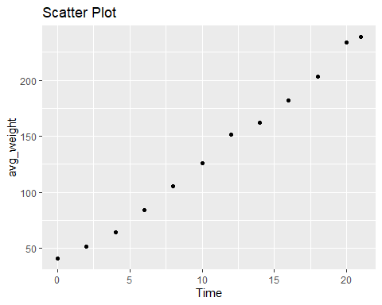

All groups:

mn_wt <- ChickWeight %>%   
 group_by(Diet, Time) %>%   
 summarise(avg_weight=mean(weight))

## `summarise()` has grouped output by 'Diet'. You can override using the  
## `.groups` argument.

mn_wt

## # A tibble: 48 × 3  
## # Groups: Diet [4]  
## Diet Time avg_weight  
## <fct> <dbl> <dbl>  
## 1 1 0 41.4  
## 2 1 2 47.2  
## 3 1 4 56.5  
## 4 1 6 66.8  
## 5 1 8 79.7  
## 6 1 10 93.1  
## 7 1 12 109.   
## 8 1 14 123.   
## 9 1 16 145.   
## 10 1 18 159.   
## # ℹ 38 more rows

Plot:

ggplot(data=mn_wt, aes(x=Time, y=avg_weight, color=Diet))+  
 geom_point()+ggtitle("Scatter Plot")

